Interface Redesign

*Allaroundinc.com*

Geoffrey Walchak

Information Architect

WEB Associates

Table of Contents

Executive Summary 3

Analysis of Current Interface 4

Layout 4

Color and Graphics 4

Interface Elements 4

Interface Design: Strengths 5

Interface Design: Areas for Improvement 6

Redesigned Interface Wireframes 8

Home Page 8

Sub Page 9

Analysis of Redesigned Interface 10

Implementation Options 11

Approach 1: Fixed-Width, Left-Aligned 11

Approach 2: Fixed-Width, Centered 12

Approach 3: Fixed-Width and Variable-Width Columns 12

Recommended Implementation 12

Appendix A 13

Figure 1: Home Page Top 13

Figure 2: Home Page Bottom 13

Figure 3: Sub Page Top 13

Figure 4: Sub Page Bottom 14

## Executive Summary

Allaroundinc.com contracted with WEB Associates to create a new interface layout for their website (<http://www.allaroundinc.com>). Usability testing results, combined with a history of user complaints concerning the current interface design, prompted this redesign. Common user complaints were the excessive length of pages, the necessity of scrolling in order to navigate, and confusion between which images are used for navigation and which cannot be clicked. The interface redesign targets these issues, as well as others, offering a solution that addresses and resolves the problems.

This report is organized into four major sections, with an appendix containing screenshots of the current home page and sub page design. The sections are:

#### Analysis of Current Interface

* The current interface is deconstructed into component elements and the existing design is evaluated based on interface design principles and Gestalt principles.

#### Redesigned Interface Wireframes

* Digital wireframes, showing placement and arrangement of interface elements, are presented for both home page and sub page.

#### Analysis of Redesigned Interface

* Improvements in the proposed interface are discussed, as well as how the new interface addresses limitations in the existing design.

#### Implementation Options

* Three approaches to implementing the redesigned interface are presented, with a consideration of their advantages and disadvantages. The recommended approach is identified.

The redesigned interface offers a number of advantages over the existing interface, including the following enhancements:

* Entire home page now visible ‘in the fold’
* Page lengths are shortened, which reduces scrolling
* Global navigation and header are truncated to allow more website content
* Photo ‘bucket’ images and carousel images are combined into one carousel
* Images on home page are consistently clickable and allow for alternative navigation
* Sub page is centered, which is consistent with home page
* Layout (fixed-width and variable-width, centered) reads better on low resolutions

## Analysis of Current Interface

### Layout

* The homepage interface for Allaroundinc.com (see Appendix A, fig. 1) uses entirely fixed-width centered elements for its images, navigation, header and footer.
* The sub page interface uses a mixture of fixed-width left-aligned and fixed-width centered elements. The images are centered in their respective columns in line with header and global navigation (see Appendix A, fig. 3).
* The fixed-width elements of the current interface have no break-points and therefore remain the same size in small browsing windows, and are designed for optimal display at 1024 x 768.

### Color and Graphics

* Current color palette contains both warm and cool colors on the homepage and subpage. Warm colors include red and yellow in the logo, while cool colors such as green and blue are dominant in the background image and supporting images.
* Header with logo is dominantly white, with yellow and red, the navigation bar is black, and the page background image is blue, photos prominently contain green to display company’s lawn services.
* Home page carousel contains three photos at 214 kb each, with six smaller images below at 24.7 kb each.

Total homepage size equals 636.3 kb which requires approximately 130.8 seconds to download and render on a 56k modem (calculations based on tests run at Web Page Speed Report http://analyze.websiteoptimization.com/wso)

### Interface Elements

The Allaroundinc.com interface contains the following elements, which will be brought forward in some form (modifications are made to certain elements) into the redesigned interface:

* Header
* Global navigation
* Carousel
* Business phone number
* Graphics
  + Photographs
  + Logo and Tagline
  + Twitter and Facebook links
  + Contact Us button
  + Home button
  + Background image
* Footer navigation containing only external links to Hibu.com

### Interface Design: Strengths

The primary strength of the current Allaroundinc.com interface is its adherence to certain interface design principles and to some of the Gestalt rules of visual perception.

* The site utilizes a fixed-width centered layout for its home page which eliminates many interface design concerns regarding negative space and symmetry.
* The Gestalt rules of proximity are properly utilized in the site’s sub page, with respect to the two-column layout. The left column (see Appendix A, fig. 3) populates 1/3 of the space while the main/right column populates 2/3, which are sized properly to remain centered below the header. Such is also an adherence to interface design principles of alignment, balance, and consistency.
* In the home page, the Gestalt rules of connection and closure are used to good effect in the six image links below the carousel. They are grouped together in a specific section of the interface and are the same size.
* The interface layout in home page and sub pages adhere to interface design principles in their simplicity, consistency, and alignment. Evidence of this is shown by the site’s content never growing wider than the header/global navigation, and is displayed neatly below it.

Additional strengths in the current interface pertain to printability and line lengths which are consistently in relative position to related images.

* In the home page, line lengths are kept short, as descriptors to the hyperlink text above them. This allows line lengths to stay within its boundaries.
* In the sub page, printability is of no concern, as the page length allows for more text as the author wishes. Page length is dictated by the size of the pictures on the left column, not the length of the text (see Appendix A, fig. 4)

### Interface Design: Areas for Improvement

Limitations in the current interface center on insufficient use of screen real estate above ‘the fold’; current interface design requires scrolling to view, both on homepage and subpage. Subpages utilize inconsistent spacing methods and inconsistent image sizes, resulting in varying degrees of height, while adhering to two-column fixed-width centered layout principles.

* There is too much ‘dead space’ (extra white space serving no function) to the left and right of the carousel. This is also observable in its optimal resolution of 1024 x 768.
* Carousel contains only three images that serve no extra functionality or linking, and pushes navigation items partially below ‘the fold’ (require scrolling to view).
* The six images below the carousel have limited functionality; some images are clickable, while others are not. Inconsistent navigation principles are confusing to the user, and in this event, the user is expected to use global navigation instead.
* The text below the image titles (e.g., “Landscaping”, “Tree Services”) uses inconsistent punctuation and vague syntax. For example, “what do you need done?” ends with a question-mark, yet the text below other images bears no punctuation. The phrase “(Eric in tree at Lurie Terrace)” should be removed, as the information is incomplete and lacks context.
* Drop-down boxes for global navigation items are unnecessarily wide, and are not reflective of the width of the text, nor the width of the parent navigation item. Furthermore, the right-most global navigation item ‘photo gallery’ has its drop-down box cropped to meet the width of the header. This conflicts with the website’s symmetrical design.
* Lower resolutions (e.g., 640 x 480) encounter difficulties with the website, although those issues mainly deal with horizontal scrolling and having parts of the global navigation fall outside of the horizontal fold. In low resolution, the header, global navigation, and carousel account for the entirety of the viewable real estate.

Horizontal scrolling is also necessary in 800 x 600 resolution in order to view both website content and global navigation.

* Sub page contents are not spaced consistently below the header. In some cases, the main photo (see Appendix A, fig. 3) touches the global navigation, yet, in other cases, such as in the photo in Appendix A, figure 3, the photo is spaced appropriately in accordance to the spacing on the home page and left column.

The most significant limitation is the size and position of the header with global navigation, and negatively impact the utilizable real estate.

* The current size of the header, combined with global navigation, is too tall to allow many crucial elements of the home page to sit above ‘the fold’. With a truncated header that reaches the edges of the browser window, the home page can abandon its current constraint of having one-inch margins on the left and right.
* Utilizing a truncated header in the sub pages allow for a three-column layout, with bucket images surrounding body text. Such a change will utilize the interface design principle of consistency, as the website will maintain a centered layout, even when navigating its sub pages.

A website that is centered and symmetrical in the home page should have centered and symmetrical elements in its sub pages to minimize user confusion; these practices are not followed in the current interface.

## Redesigned Interface Wireframes

### Home Page



### Sub Page



## Analysis of Redesigned Interface

The redesigned interface for Allaroundinc.com offers a number of benefits over the existing interface design and addresses the limitations identified by users of the current website. One of the most significant improvements concerns page length and what is visible ‘in the fold’ (without scrolling).

* Reducing the height of the header and increasing the width allows for more website content to be shown upon loading, with no scrolling necessary. Logo, slogan, phone number, contact information, and external social media links are still present; nothing is removed from the existing header.
* Retaining the carousel and increasing its size to meet the size of the browser window (variable width).
* Removing the six images, their titles and descriptors, and reincorporating them into the carousel. Sample carousel has nine (9) images, which contain the three existing carousel images plus the six images that were once stacked.
* Text overlay on carousel images allow for the image to be full-size, without lacking in necessary information. Entire image is clickable, as well as “learn more” prompt.
* Reducing brightness of carousel images for easier viewing of white text overlay.
* The “home” button on global navigation bar is separate from other global navigation items and placed just below the logo. This is done to reduce user confusion when navigating.

Another significant enhancement in the redesign is the change of layout in the sub page.

* The shorter, wider header allows for a three column approach, rather than the existing two column layout. This allows for a centered home page and sub page, where the existing design used inconsistent layouts.
* These changes minimize the ‘dead space’ in the left and right margins of the page. Page length is dependent on the amount of text, which allows for better printability and visibility.
* Decreased size of text by 30%, which allows text to be centered between supporting images on either side. This allows for more information to remain ‘above the fold’, reducing page length. Low visibility users, who use lower resolution and zoom tools, should see little change to their browsing habits under the redesigned conditions.

The final improvements concern better placement of logo and contact information which combines header and global navigation.

* Logo and slogan are now side-by-side instead of stacked. This allows for more efficient use of vertical space.
* Reduced size of phone number to allow more vertical space.
* Widened global navigation’s drop-down menus will no longer ‘bleed’ into imposed page margins, as page margins no longer exist.

## Implementation Options

The redesigned Allaroundinc.com interface can be implemented a few different ways, with each approach offering different advantages and disadvantages.

### Approach 1: Fixed-Width, Left-Aligned

* The design could be coded in a left-aligned and entirely fixed-width fashion, using one column of fixed size for the home page, and three columns for sub pages.
* In the home page, the full-size image carousel would be the only object of concern. In a fixed-width layout, this image would remain the same size in small browsing windows.
* In the sub page, the left-most column contains the pre-pay blurb, the ‘request a quote’ button, and one supporting image.
* The middle column would contain the body text for the sub page, and would be the longest column. Page length is dependent upon the length of body text plus sponsors and page footer.
* The right-hand column in the sub page contains any additional supporting images.

In this layout, images should populate the entire width of the column to remain consistency in the design throughout each subpage. In the current design, image heights vary between sub pages, which create an inconsistent viewing experience for the user.

### Approach 2: Fixed-Width, Centered

* The second approach to coding this interface is substantially similar to the first approach, except that the entire design is centered on the page.
* This approach eliminates the need to resize supporting images on sub pages to meet the column widths, as the images would be centered in this layout.

A point of concern with this layout, however, is that images should consistently be the same distance away from the header and global navigation. One method of achieving this is by creating a twenty (20) pixel gap below the header and global navigation.

### Approach 3: Fixed-Width and Variable-Width Columns

* The third approach combines both fixed-width and variable-width elements.
* In the home page, the carousel image would expand to fill the available window space.
* In the sub page, the left-hand and right-hand columns would be fixed width, while the middle column would become variable-width. This allows for the body text to retain its size, while giving less importance to supporting images on either side.

This is achieved by placing these images below the body text in small browsing window settings.

* The disadvantages are that the ability to “request a quote” via the button, would be pushed below the body text in small browsing windows. However, if the customer felt compelled to request a quote after reading the body text, the button would be visible to the user after reading.

### Recommended Implementation

Of the approaches described, the third approach is recommended. That approach helps to alleviate user confusion when browsing in low-resolution and/or small browser windows. While the primary goal in the redesign of reducing page length can be achieved in any of the three approaches, only the third implementation allows for this flexibility.

A fourth option, an entirely variable-width layout, is not advised as control over page element alignment is seriously compromised.

## Appendix A

### Figure 1: Home Page Top



Figure 1: Home Page Top (1440x900 resolution, 17 inch monitor, window maximized)

### Figure 2: Home Page Bottom



Figure 2: Home Page Bottom (1440x900 resolution, 17 inch monitor, window maximized)

*Figure 3: Sub Page Top*



Figure 3: Sub Page Top (1440x900 resolution, 17 inch monitor, window maximized)

### Figure 4: Sub Page Bottom

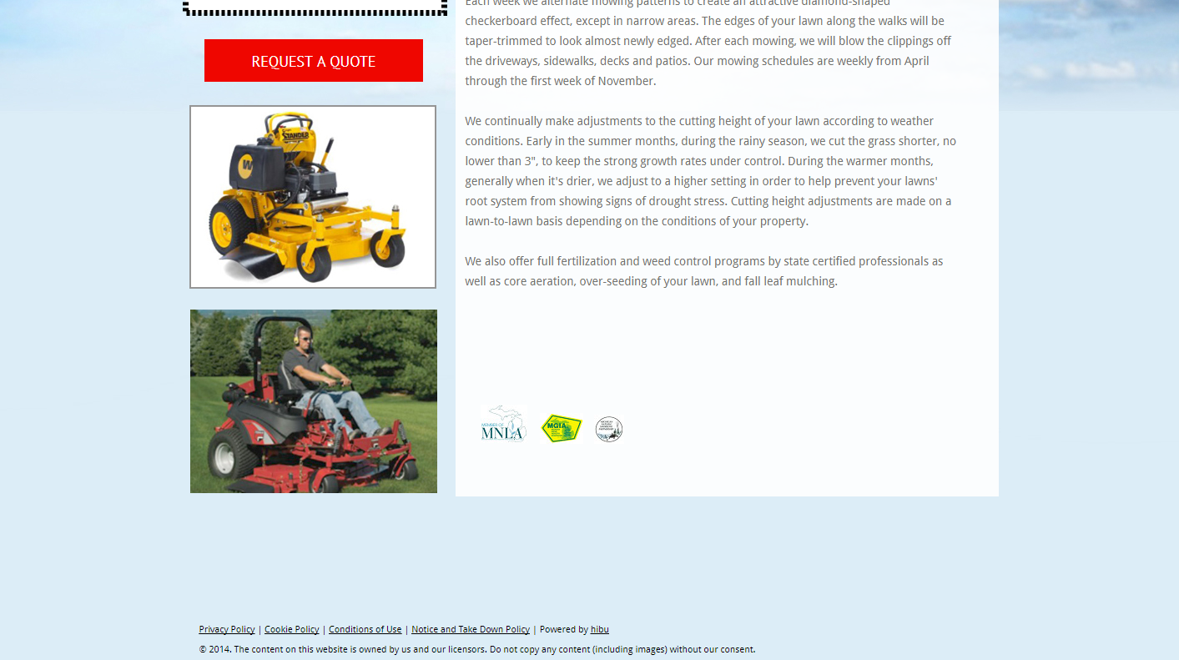

Figure 4: Sub Page Bottom (1440x900 resolution, 17 inch monitor, window maximized)